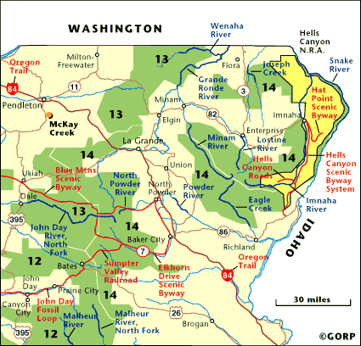
Imnaha MPG Snake River Steelhead
Following pages are an analysis of ongoing monitoring programs in the MPG by TRT identified population, an evaluation of the quality of the information, and an evaluation of what would be needed to improve the monitoring and to move toward meeting NOAA Fisheries Service monitoring guidance standards.
Evaluations shown in this document are drawn from the work completed by the Columbia River Fish and Wildlife Authority through the Collaborative Systemwide Monitoring and Evaluation Project and through direct participation of the fish co-managers, FCRP action agencies, Public Utilities, Forest Service and others.
This evaluation is a result of a workshop held at Eastern Oregon University on March 16 in La Grande, and includes edits provided by:
- Rich Carmichael, ODFW, 3/16/09,
- Gene Shippentower, CTUIR 3/16/09
- Jay Hesse, NPT, 3/20/09

MPG Population | Primary Indicator | Desired Certainty | Monitoring Needed | Current Monitoring | Data Quality & Certainty | Data Improvement Actions Needed | RPA Eligible | New Monitoring  Proposals
Imnaha River | Adult Abundance | Annual population-level estimates with a CV value on average of 15% or less.  Power analysis calculated for data? | Natural-origin Spawner Abundance | - ODFW weir in Sheep creek  - Sheep Cr weir CV=0  - Nez Perce weirs in Lightning and Cow Creeks from 1999 to 2007, LSRCP Evaluations Contract  - ODFW single pass non-randomly selected sites Index area ground redd counts surveys lower 6 miles of Camp Creek (non-representative spawning area). Survey begins after the peak run. The number of redds counted divided by the number of miles surveyed.  - NPT operated resistivity fish counter installed in Camp Creek in 2008 to correlate redd counts to abundance. Video validates species and origin. LSRCP funded  - NPT started operation of weir based escapement estimates in Horse Creek in 2008. LSRCP funded  - ODFW estimates sport harvest o f hatchery-origin fish. | - Index ground redd counts have no confidence estimates  - Methods Anderson 1977  - Information is tributary specific and may not be representative of the basin  - Need to evaluate accuracy and precision of redd count expansion techniques  - No measurement of PHOS with spawning ground surveys  - Cow Creek Ave CV = 10.8 ranging between 3.9 & 20.5  - Lightning Creek Ave CV =13.6 ranging between 3.7 & 29 | - Adult escapement data or Spawner abundance ?????  - Estimate o f catch and release mortality impacts in Snake River and Imnaha river areas. |  | NPT proposed population abundance and distribution study 200205600  Snake Basin Comanagers recommend GSI characterization based on Lower Granite Dam subsampling.  Snake Basin Comanagers recommend proportional mark-recapture estimate of escapement based on Lower Granite Dam PIT tagging of adults and recapture using extended PIT tag array coordinated with ISEMP tagging.  NPT proposed to increase tribal steelhead harvest monitoring under project ???????
Imnaha River | Adult Productivity | Adult/Adult ratio with low σ² | - Sex ratio  - Hatchery %  - Cohorts (define or use “age”  - Harvest | - ODFW Weir data is used to calculate adult to adult spawners for the area upstream of Little Sheep Creek weir.  - PHOS calculated for Little Sheep and Horse Creek (ongoing), Lightning and Cow creeks (199-2007)  - Hatchery estimates smolt-to-adult survival rate (SAR) for transported hatchery steelhead under BPA contract #199602000 CSS not done on STT. Recent PIT tagging  NOAA conducting RRS study in Little Sheep Creek upstream of weir. Project 199???? | - PHOS estimated are inaccurate in all supplemented streams I  - NPT would argue they may be imprecise | - Need 100% CWT marking of all hatchery steelhead released without an external fin clip  - (all Imnaha subbasin releases are marked with adipose fin clip in the 2008-2017 US v OR management agreement.
Imnaha River | Juvenile Productivity | Annual population-level estimates with a CV value on average of 15% or less.  Power analysis calculated for data? | - Juvenile Migrant Abundance  - Smolt/Adult ratio | - ODFW Juvenile snorkeling discontinued due to high variability of data  - Imnaha River SAR project BPA # 199701501 $324,987 NPT Operated juvenile emigration trap, calculated arrival timing and survival of hatchery and natural steelhead and chinook smolts. Trap not operated across entire migration period.  - NPT will analyze all PIT tag data from steelhead releases into Imnaha BPA# 199701501 |  | - Juvenile migration trapping across entire migration period |  | NPT proposals (SMP and NEOH M&E)
Imnaha River | Spatial Distribution | Periodic distribution estimates with ability to detect a 15% change with 80% certainty. | - Adult redd distribution  - Juvenile parr distribution | - ODFW adult redd count index surveys (Limited to Camp Creek)  - ODFW and NPT Adult weir counts (Little Sheep Creek, Horse Creek) |  |  |  | NPT proposed population abundance and distribution study 200205600
Imnaha River | Species Diversity | - Short term collection of phenotypes  - Long term collection of genotypes | - Age  - Sex ratios  - Size  - Cohort structure  - Run Timing  - DNA | - No information for fish spawning below weirs |  |  |  | IDFG prposes to implement Parentage Based Tagging (PBT) on all hatchery steelhead production started in 2008.

CSMEP Strength and Weakness document D. Ward

